410 Gauge

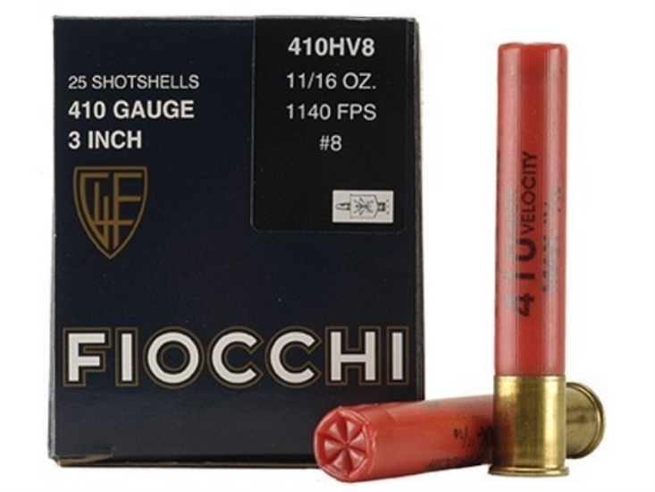

**Description:** Smaller strength shotgun shell that produces a smaller recoil than other shotgun shells.

**Dimensions (LxWxH meters):** 0.013 m x 0.013 m x 0.0765 m

**Weight (kilograms):**

**Asset Type:** Ammunition

**Destructible:** Yes

**Grabbable:** Yes

**Animations:** Name1, Name2

**Material Descriptions:** Steel <Image>

**Concepts:** <Front View>, <Right View>

**Other Comments:** Commonly known as 410 Gauge, but proper name is 410 Bore.